Van Usage Rules
All designated Vision Van operators must agree to operate the vehicle in accordance with the following guidelines:
- Operator must be an SD Lions Club Member
- Operator must maintain a valid and current driver’s license.
- Operator must provide proof of a current driver’s license upon request.
- Operator will immediately notify the SDLF of any citations received or any damage to the Vision Van.
- Operator must follow all safe driving practices and comply with all traffic laws.
- Operator will ensure that all occupants are properly wearing safety belts while the vehicle is in motion.
- Operator is responsible for ensuring that the Vision Van is cleaned and properly maintained after each use.
- Operator is responsible for parking the Vision Van in a safe and legal location.
- Operator will not operate the Vision Van while impaired by fatigue, medication, drugs, or alcohol.
- Operator will ensure that all equipment (e.g., table, chairs, screening equipment) is properly stored and returned to the Vision Van after use.
- Operator will not apply any adhesives, decals, magnets, or other materials to the Vision Van, as it is professionally wrapped.
- Operator will not take the Vision Van through an automatic car wash; only hand-washing is permitted to protect the professional wrap.
Vision Van Instructions
Vehicle Insurance and Registration
This information is kept in the middle console between the two front seats. DO NOT remove this from the van for any reason.

Gas/Mileage
The gas tank is located on the driver’s side. Just to the right of the door.
Please fill up the tank when you club is done using the van.

Battery Power
The van must be running or be plugged in to have power. The outlet behind the AC unit will be the only working outlet when plugged in. The plug-in cord is located on the outside behind the van under the bumper on the right side. There is an extension cord located in the back storage cabinets in the van. Plug into any standard outlet.
The outlets on the wall do not work. Please use the Portable Battery to power the printer and charge the screener.

Portable Battery

Turn on the Battery-AC on/off switch. Plug printer into battery outlet.
**Please remember to TURN OFF the battery when done using it**
Charge cord for the battery is in the case. If the battery gets low on power, please recharge it.

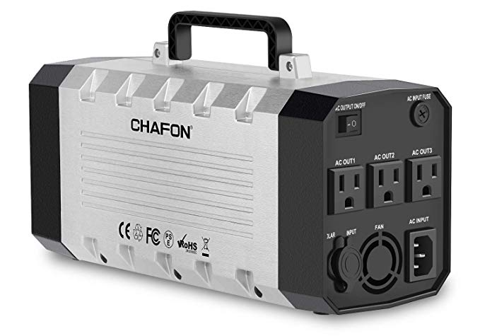
Heating and Cooling
The rear heat is controlled from inside the van cab. The switch is located on the left side of the steering wheel. This will only run when the engine is running. The vents are located above the bench in back. Make sure they are open when in use.
The rear air conditioner is controlled from inside the van cab. The switch is located on the left side of the steering wheel. This will only run when the engine is running. The vents are located above the bench in back. Make sure they are open when is use.
Air Conditioning Tower. This will be used to cool the van when you can’t leave the van running for long periods of time. Make sure the van is plugged in. Pull the tower out of the corner. It needs air flow around it to vent properly. Attach the hose to vent. *See instruction page*
**DO NOT PLUG AC TOWER INTO PORTABLE BATTERY**

Equipment

Stairs- The stairs are about 30 lbs. Please use caution when moving them around. They have wheels on one side so they can be tipped to the side and rolled like a cart.
- Unbuckle the safety belt
- Secure the safety belt straps with the Velcro on each side
- Slowly lower the stairs to the ground. Two people is recommended for this step.
- Tilt the side and roll to the van opening
- Unstrap the side rails from inside the van wall
- Place the rails into holes on the stairs and tighten each screw.
Take down:
- Loosen rails and place them against the inside wall of the van. Bottom Pegs go in first.
- Secure rails with Velcro Straps
- Tilt stairs and roll to back of the van
- Lift into back of the van. Two people is recommended for this step.
- Secure using the safety belt.

Safety Cones-To be used as you see fit. Recommended for outdoor events to warn vehicles of children being near. These are to be stored in the upper cabinets

Task Chair- This is for the screener to use if needed. DO NOT Let Children use this chair. It is unsafe and can roll out from under them. Secure using the bungee cord when not in use.

Folding Table and Chairs- Use if needed. Put back into designated area when done. One folding table and four folding chairs.

Free Vision Screening Signs- Set outside the van or along the sidewalk for added signage. Lay down flat when the van in motion or secured using the wall straps.

How to set up Portable Air Conditioner Tower
- Pull Tower out away from the wall. Needs to have air flow around it.
- Remove wall vent cover. Place cover in a secure place. (In cupboard or back shelf)
- Attach the end of the hose to wall vent. Expand the hose end and rotate counterclockwise.
- Attach Joint A adapter to the exhaust hose. Expand the hose and rotate.
- Attach the hose to the A/C Tower. Slide into grooves until it clicks into lock on top.
- Press power button on top of the tower and set desired temp.
Step 1 Step 2 Step 3
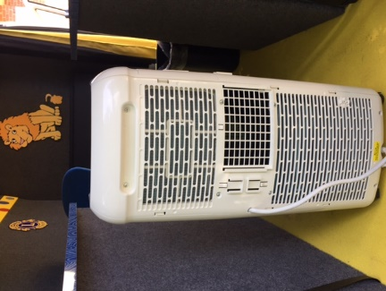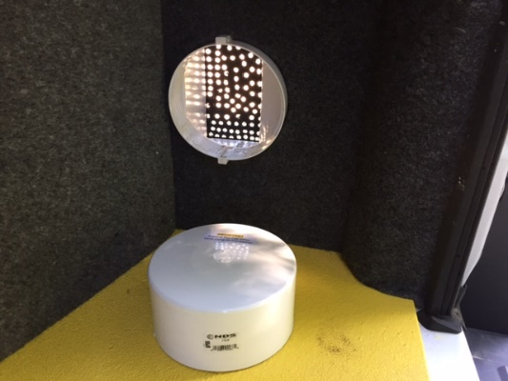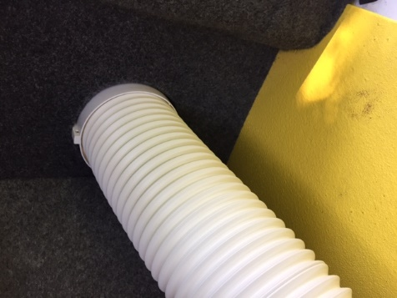

Step 4
 Joint “A” Adapter and Exhaust Hose 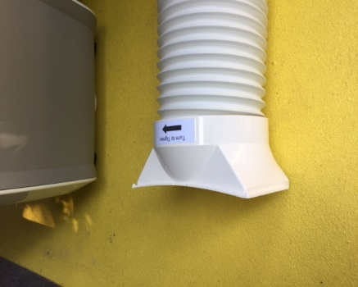
Step 5 Step 6
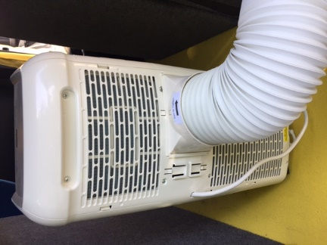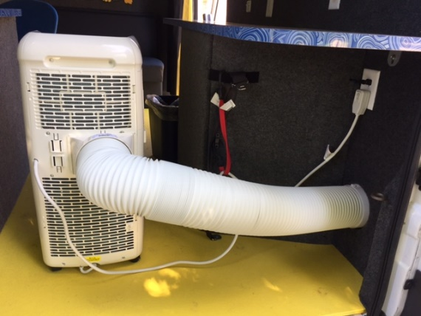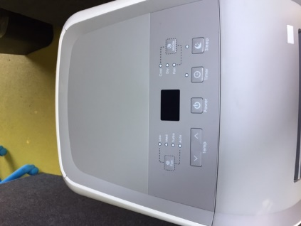

Van Clean Up-Take Down
- ALL EQUIPMENT GOES BACK INTO PROPER PLACE AND SECURED (See Picture Guide)
- All consent forms must be labeled with a after screening cover sheet. They are in the van storage compartment along with envelopes to put them in. Please don’t leave consent forms loose in the van.
- Wipe down counter tops, stair rails and bench. Sani Wipes are in the storage compartment.
- Sweep the floor and empty garbage if needed.
- Top off gas tank. If you get the van with an empty or low tank, please try to replace what was used.

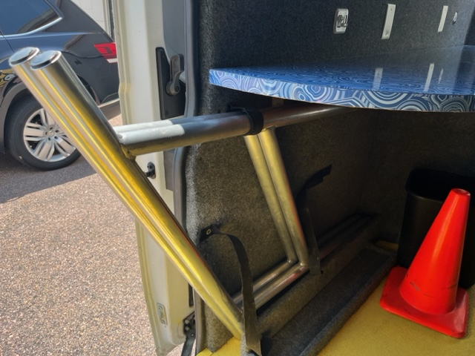
Stair Rails Slide in pegs first
and secure with Velcro.

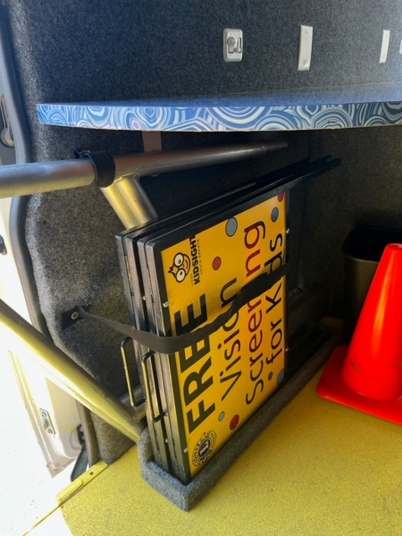
Metal Signs Slide in front of rails
and secure with Velcro.

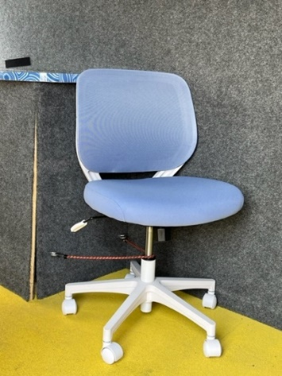
Secure task chair with bungee strap.
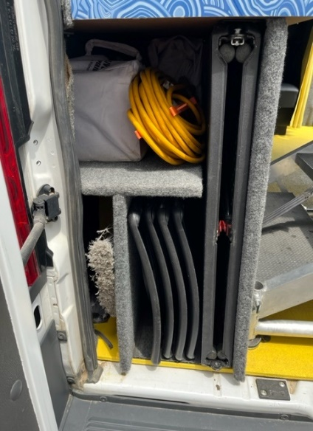
Table and Chairs, Tent and Broom go into back storage compartment.

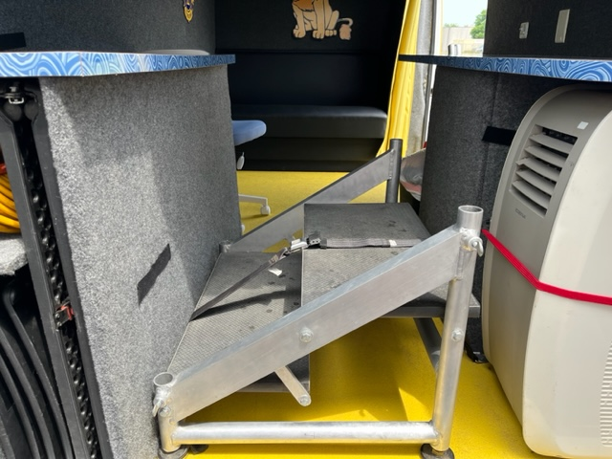
Stairs go in back and secure with seatbelt
across the top.

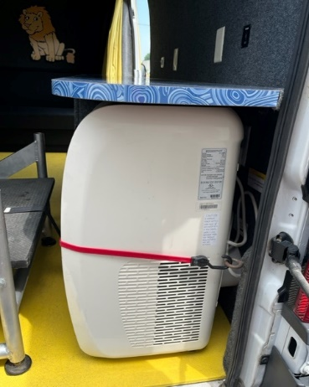
AC Unit slides under counter and secure with bungee strap.

