EVENT VISION SCREENING – FULL PROCEDURE
(Free-Screen Method – No Personal Data Entry, No Printer Required)
Supplies Needed
- Vision screening device
- Event multi-parent signature consent form
- Stickers and sunglasses (when available)
- QR-code referral postcards
1. Consent Collection
- Confirm the parent or guardian has signed the event consent form before screening.
Sample of Form:
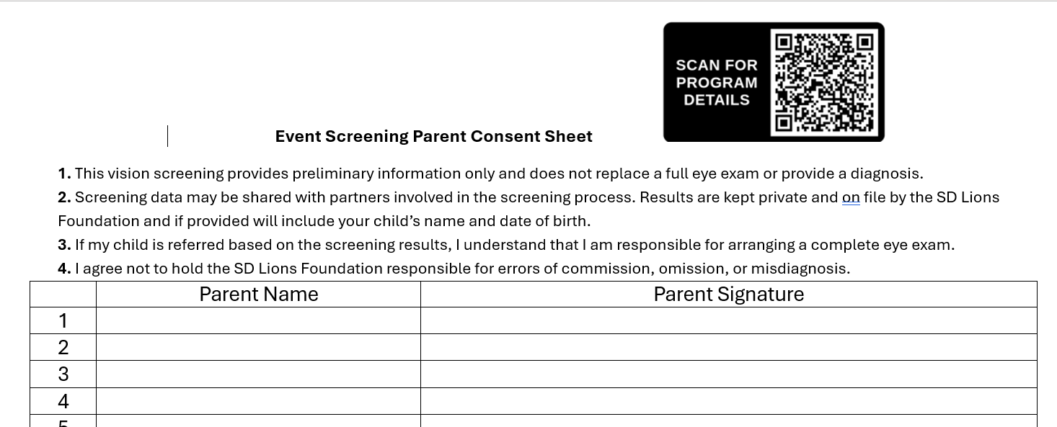
2. Device Startup
- Press and release the Power button.
- Allow ~30 seconds for the Home Screen to appear.
- Ensure the device battery level is adequate for the event.
3. Select “Age Range” (Screen Without Typing Data)
To run screenings without entering personal information:
- From the Home Screen, select: Tools → Age Range
- Choose the appropriate age range for the child.
- This allows screening with age only — no name, DOB, or gender required.
- Additional details can be added later if needed, but for event screenings they are not used.
4. Begin the Screening
- Tap Start to begin the binocular or monocular test.
- Position yourself approximately 3 feet from the child.
- The device will use a fixation target and audio cues to keep the child’s attention.
- Hold the device steady until the reading completes.
- Results will appear automatically on the touchscreen.
5. Understanding the Results
- The device will display either:
  - PASS (no risk factors detected), or
  - REFER (one or more risk factors detected)
- Results can be printed or saved, but for event screenings:
  - You will not print, and
  - You will not manually save the record.
6. If the Child PASSES
- No postcard is given.
- When the device asks “Save this record?” → select NO.
- Return to the Home Screen to screen the next child.
- Important: Even when you select “NO,” the device still automatically stores the screening data in its internal History.
7. If the Child is FLAGGED
- Fill out a referral postcard for the parent.
Example of postcard

- Mark the specific condition(s) the child was flagged for.
- Hand the postcard to the parent and encourage them to scan the QR code for more details.
- When the device asks “Save this record?” → select NO.
- Return to the Home Screen to continue screening.
8. Continue Screening
- Repeat the process for each child.
- Do not enter names, dates of birth, or any personal identifiers into the device.
- Stickers or sunglasses may be given to all children to create a positive experience.
9. After the Event
- Power off the device and return it to its case. Be sure power cord is put into the screening case.

