Event Screening Parent Consent Sheet 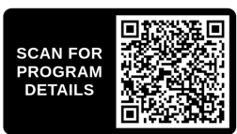
1. This vision screening provides preliminary information only and does not replace a full eye exam or provide a diagnosis.
2. Screening data may be shared with partners involved in the screening process. Results are kept private and on file by the SD Lions Foundation and if provided will include your child’s name and date of birth.
3. If my child is referred based on the screening results, I understand that I am responsible for arranging a complete eye exam.
4. I agree not to hold the SD Lions Foundation responsible for errors of commission, omission, or misdiagnosis.
 | Parent Name | Parent Signature
1
2
3
4
5
6
7
8
9
10
11
12
13
14
15
16
17
18
19
20

